**Compsci 250p HW 0**

**Folder description**

* codebase: List all necessary files generating from the steps in HW0
  + Makefile: step 32
  + main: step 32
  + main.cpp: step 9
  + main.txt step 39-40
  + typescript: step 41
  + create_script: step 37
* images: List all screenshots from important steps, and the file name is the consequence of that step.

**Some important screenshots**

**Step 30 : Run Valgrind**

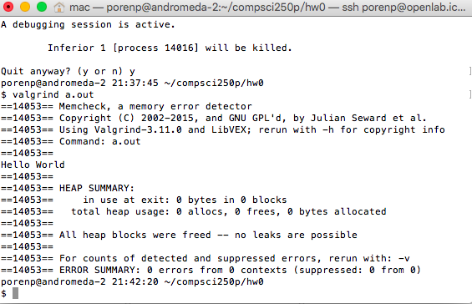

30_1 execute: valgrind a.out

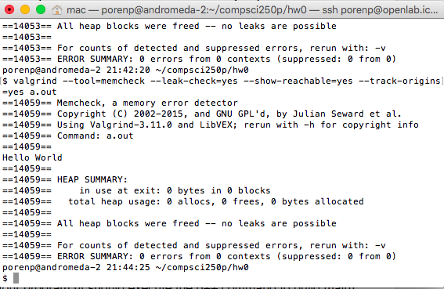

30_2 execute: valgrind --tool=memcheck --leak-check=yes --show-reachable=yes --track-origins=yes a.out

**Step 33: Run make**

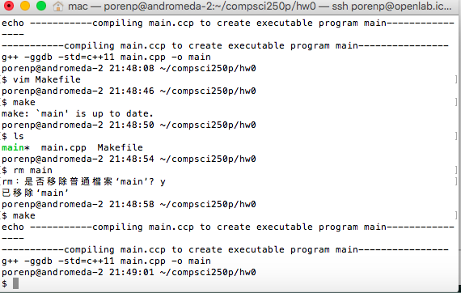

33: execute make

**Step 34: Run file generate by Makefile**

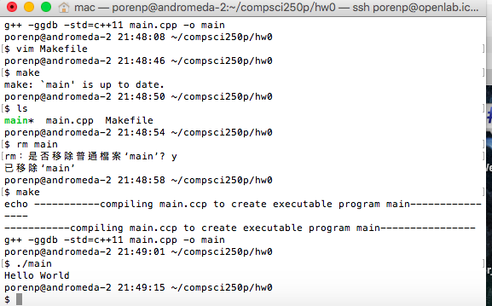

34: execute main generated by Makefile